THE MOON FORCE

To JEFF BEZOS, ELON MUSK, Jared Isaacman, CHAIRMAN OF THE JOINT CHEIFS OF STAFF, THE JOINT CHEIFS OF STAFF, THE VICE PRESIDENT OF THE UNITED STATES, THE PRESIDENT OF THE UNITED STATES, His Excellency, Donald J. Trump.

"All life is intertwined. We see the great peaks mirrored in water. Stillness. Wholeness. Renewal. Reflection leads us to restoration.”
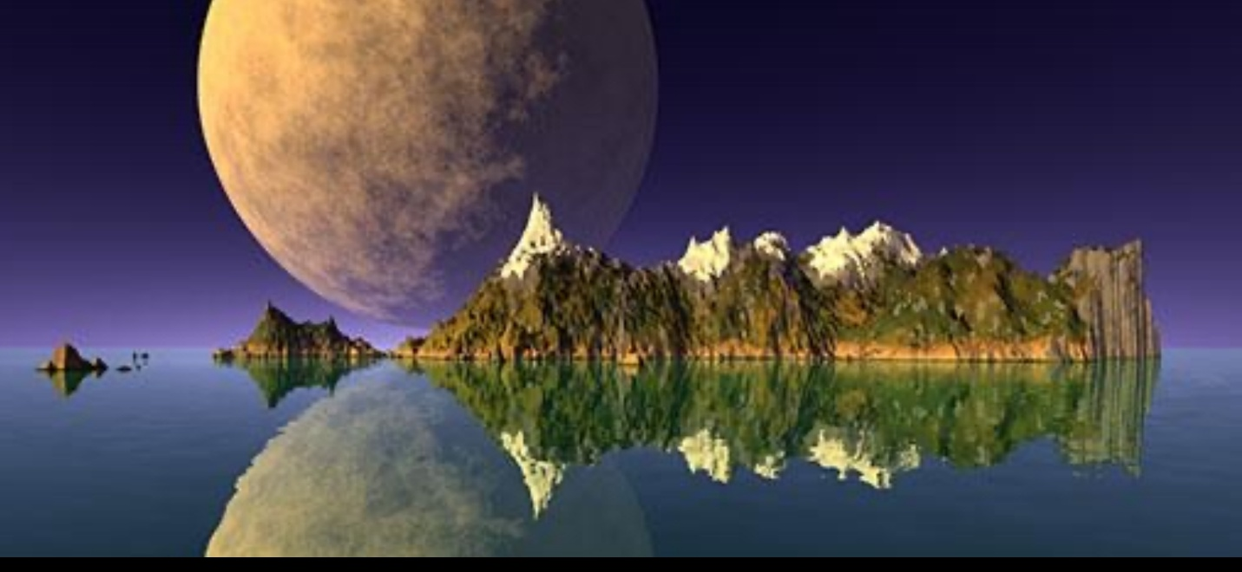
Blessed State. F. Ken Musgrave. 1988.
THE MOON FORCE
We need a concept called THE MOON FORCE. The Moon Force is several things. It is a continuous presence on the moon, manned with American Moon Force Soldiers. This can be thought of, nearly just like the ISS. A presence in space, that’s fueled, fooded, and with a service rotation. That is the first and most paramount. There are several reasons for this. First, Imagine after Louis and Clark, we planted a Flag in Oregon then, simply, let it rot for 57 years. No. That would have been a non-starter for that generation and, every generation after. As it should be for us today. As it will be. We own the Moon. That Flag that was planted was an American Flag. There is no reason ever, any other flag should ever find itself upon the surface of the moon. That is the first thing.
However, the next issue is our most precious asset, our overwhelming and unique satellite infrastructure. The Soviets quickly built a nuclear weapon, as did our allies. Since the mid-eighties, we have stepped well ahead of any other nation in terms of our satellite systems capabilities. However, other nations are now very much aware of that. They know that, not if but, when they beat American, in their minds, it will only happen once they have surpassed us on the satellite plane. Its possible that they are not aware of how much work they have before them but, they are on the chase. Part of that pursuit will be to impede if not derail our satellite systems. Not via physical destruction. We all know that this invokes Kessler which makes any and all satellite operations null and void. That will not be the angle that they will persue. We can think of our current technological dynamic of Satellite Orbitals, Satellite Constellation, and Satellite Ground Control as a One Dimensional Plane. Some of the measurement axis are self-cancelling, effectively manifesting our viewing angle into a one dimensional axis. Under normal peace time operations, this is okay and fine. However, in a clandestine, sneak-attack, stealth maneuver to effect a take-over event as we know that the hostile region of Communist China intends to do, this paradigm resides with grave levels of operational risk. It truly sits with overwhelming risk.
If you can take for granted that the current satellite operating paradigm is a one-dimensional system, then, you can understand and comprehend immediately not only the benefit but, in truth the absolute need for The Moon Force. The Moon Force gives us a TWO-DIMENSIONAL Monitoring, Control, and Retrieval (or Recovery) paradigm. This means that, when our satellites are stolen out of our hand, which could be done by ghosting earth-satellite and satellite to satellite signals however, a Moon-satellite, Moon-earth, Moon-satellite-earth command and control plane makes this much much more difficult.

What SDI was to the Nuclear Weapon, the Moon Force is to our most, absolutely incredible, lovely and pristine, satellite infrastructure.

Keep America Safe. Keep America as the Good Shepard to the World. For the Enemy will never be that. Please consider and, I hope, build The Moon Force --- NOW.

Sincerely,

Brian Abbott
Founder and CEO
Agentiq Capital, Inc.
https://agentiqcapital.com

What is the Moon Force

Why we need the Moon Force

